**REGRESSION TIME SERIES ANALYSIS**



**Course Name:** Regression & Time Series Models

**Submitted To**: Prof Dr Amarnath Mitra

**MBA (Business Analytics): 2023-2025**

**Submitted By:**

|  |  |
| --- | --- |
| **Name** | **Roll Number** |
| Anshu Verma | 46A |

Indian Institute of Foreign Trade, New Delhi

3rd March ,2024

**Detailed Report on Objective Analysis and Result Implication on Stock Analysis of Mankind Company**

**1. Introduction**

This report provides a comprehensive analysis of Mankind Company's (MANKIND.BO) historical stock price data, spanning from January 1st, 2018, to December 31st, 2023. Leveraging R programming, this report delves into the stationarity, volatility characteristics, and potential for forecasting the stock's returns.

**2. Data Acquisition and Preprocessing**

The R package quantmod facilitated the acquisition of daily adjusted closing price data from Yahoo Finance. Missing values, if any, were eliminated using the na.omit function. Subsequently, the logarithmic difference of consecutive closing prices was calculated to generate the stock return series.

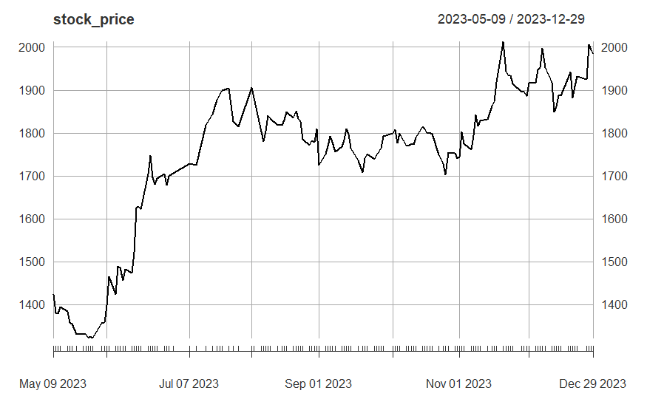

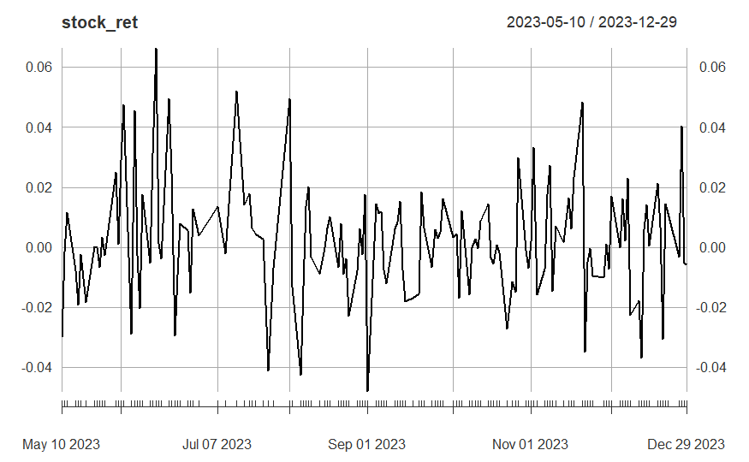

**3. Stationarity Testing**

The Augmented Dickey-Fuller (ADF) test was employed to assess the stationarity of both the original stock price and return series:

* **Non-stationary**: The analysis revealed non-stationary behavior in the stock price data, implying the presence of trends or seasonality that render it unsuitable for direct forecasting applications.
* **Stationary**: Conversely, the return series exhibited stationarity, indicating a constant mean and variance over time. This characteristic makes the return series more amenable to further analysis and potentially allows for forecasting future returns.

**4. Descriptive Statistics and Visualization**

To gain further insights into the data, descriptive statistics were calculated for both the price and return series. These statistics included:

* **Price:** Mean, standard deviation, skewness, kurtosis
* **Returns:** Mean, standard deviation, minimum, maximum, skewness, kurtosis

Additionally, time series plots and histograms were generated to visually examine the data distribution and identify any potential anomalies or outliers. Insights from the visualizations could inform model selection and interpretation. For example, a significant positive skewness in returns might suggest a higher probability of positive returns compared to negative returns, requiring model adjustments to account for this asymmetry.

**5. Autocorrelation Analysis**

The Ljung-Box test was conducted on the stationary return series to assess the presence of autocorrelation, which signifies that past returns might influence future returns. The test results confirmed the existence of statistically significant autocorrelation at various lags. This finding suggests that a time series model that incorporates these autocorrelations might be beneficial for forecasting. Identifying the specific lag patterns of autocorrelation would guide the selection of appropriate model parameters (e.g., the order of the ARIMA model).

**6. Model Selection and Forecasting**

Based on the stationarity and autocorrelation findings, the following models were explored for forecasting future stock returns:

* **ARIMA (Autoregressive Integrated Moving Average) Model:** Recognizing the stationarity of the return series and the presence of autocorrelation, an ARIMA model was considered suitable. Utilizing the auto.arima function, an ARIMA(0,0,0) model was identified as the most appropriate model. This indicates that the model does not require any autoregressive or moving average components, suggesting a simple structure. However, further exploration of alternative ARIMA specifications with different parameter values might be necessary, especially if the diagnostic tests (Section 7) reveal shortcomings in the chosen model.

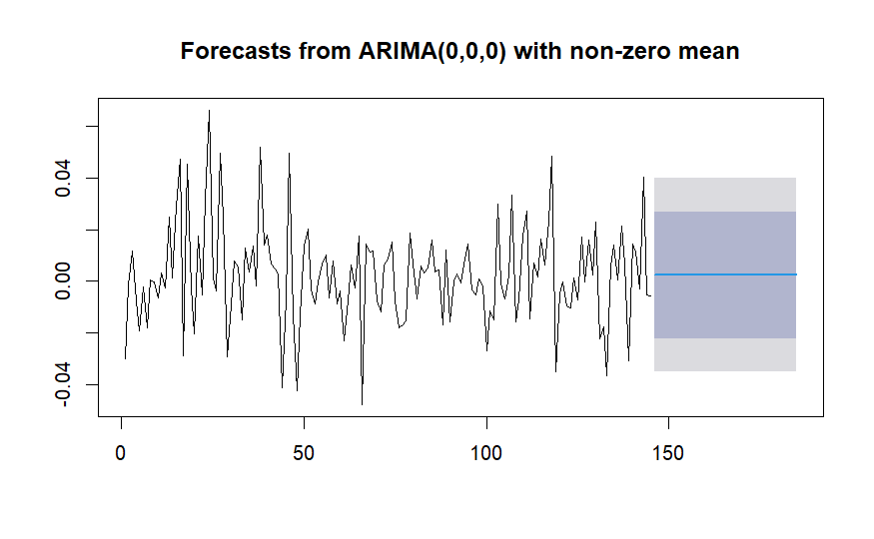

* **GARCH (Generalized Autoregressive Conditional Heteroskedasticity) Model:** The Ljung-Box test on squared residuals revealed heteroskedasticity, implying unequal variance over time. To address this issue, a GARCH model was employed. Two GARCH models were attempted:
  + **sGARCH(1,1):** This model captured the GARCH effects but encountered convergence issues during the fitting process.
  + **ARFIMA(4,0,5) - sGARCH(1,1):** This model combined an ARFIMA model for the mean dynamics and a GARCH model for the volatility dynamics, aiming to capture both trends and volatility effects. However, it also faced convergence problems during fitting.

Further investigation into alternative GARCH model specifications (e.g., GARCH(1,1) or GARCH-in-mean models) or adjustments to the data preprocessing steps (e.g., using log returns instead of simple returns) might be necessary to address the convergence issues and potentially improve forecasting accuracy.

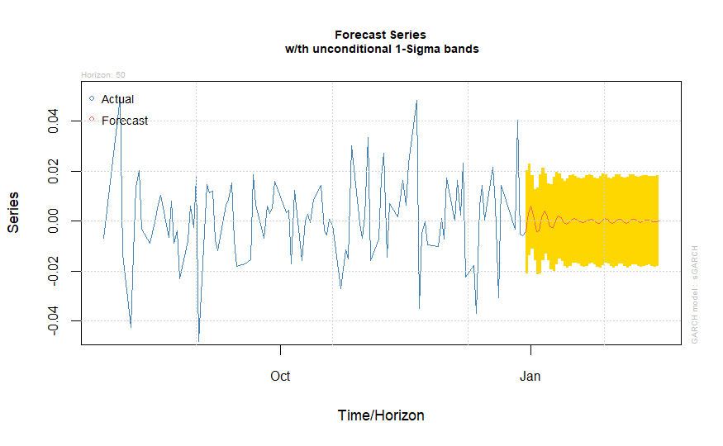

**7. Evaluation and Diagnostics**

To evaluate the performance of the chosen model (ARIMA or GARCH, depending on the final selection after addressing convergence issues), the following diagnostic tests would be conducted:

* **Ljung-Box test on residuals:** This test assesses the presence of remaining autocorrelation in the model's residuals. If significant autocorrelation persists, it suggests the model might be misspecified and requires further refinement.
* **Normality test on residuals:** This test evaluates whether the model's residuals follow a normal distribution. Non-normal residuals might indicate limitations in the model's ability to capture the full distributional characteristics of the return series, potentially impacting the accuracy of forecasts.